**What is Master-Slave Architecture?**

* Master-slave architecture is a system where a central unit, the "master," controls and assigns tasks to multiple subordinate units, the "slaves."
* The slaves execute tasks and report back to the master. This design is often used in distributed systems for efficient resource management and streamlined data processing.
* Communication between the master and slave nodes is generally uni-directional, with the master issuing commands and the slaves executing them.
* This architecture enables parallel processing and [load balancing](https://www.geeksforgeeks.org/what-is-load-balancer-system-design/), as tasks can be distributed across multiple slave nodes, thereby improving system performance and [scalability](https://www.geeksforgeeks.org/what-is-scalability-and-how-to-achieve-it-learn-system-design/).

**Diagram:**

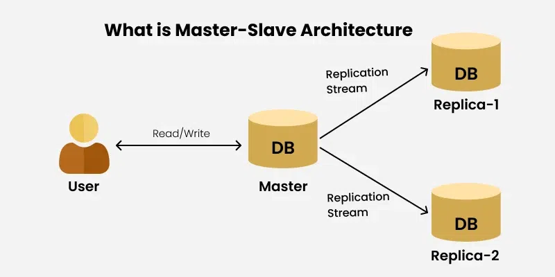

**Key components:**

1. **Master Node**: The central unit that manages and coordinates the system's operations, receiving requests, delegating tasks to slave nodes, and collecting results.
2. **Slave Node(s)**: Subordinate units that perform tasks assigned by the master, handling computations, data processing, or specific functions.
3. **Communication Protocol**: A set of rules governing how data is exchanged between master and slave nodes, ensuring reliable and effective communication.
4. **Task Distribution Mechanism**: A method for efficiently assigning tasks from the master to the slaves, optimizing resource usage.
5. **Feedback Mechanism**: Allows slave nodes to report task statuses and results back to the master, ensuring synchronization and managing errors.

**Data Flow and Communication in Master-Slave Architecture:**

1. **Task Delegation**: The master node assigns tasks to slave nodes, specifying task details and relevant data.
2. **Data Transmission**: The master node sends the necessary data to the slave nodes for processing.
3. **Task Execution**: Slave nodes process the data and perform the assigned tasks independently.
4. **Result Collection**: After task completion, the slave nodes send the results back to the master node.
5. **Feedback Loop**: The master node receives the results, analyzes them, and may trigger additional actions or tasks based on the outcomes.

**Load Distribution and Balancing in Master-Slave Architecture**

* **Even Distribution**: Tasks are assigned to slave nodes in a balanced manner to prevent overloading any single node.
* **Dynamic Allocation**: Load balancing algorithms dynamically adjust task assignments based on node capacities and current workloads.
* **Efficient Resource Utilization**: By distributing tasks evenly, the architecture maximizes resource utilization across all nodes.
* [**Scalability**](https://www.geeksforgeeks.org/what-is-scalability-and-how-to-achieve-it-learn-system-design/): Load balancing enables the system to scale efficiently by adding or removing slave nodes as needed.
* [**Fault Tolerance**](https://www.geeksforgeeks.org/fault-tolerance-in-system-design/): Load distribution enhances fault tolerance by redistributing tasks in case of node failures.

**Data copying strategies in Master-Slave architecture:**

1. **Synchronous Replication**: Every time the master updates, the changes are instantly copied to the slave. This keeps everything in sync but can slow things down because each change waits for confirmation from the slaves.
2. **Asynchronous Replication**: The master updates first, and then the changes are copied to the slaves later. This is faster but may cause a delay, meaning the slaves could have slightly outdated data.
3. **Periodic (Batch) Replication**: The master collects changes over time and sends them to the slaves all at once. This helps reduce system load but means the slave data is only up-to-date as of the last batch update.

**Challenges of Master-Slave Architecture:**

1. **Synchronization**: Keeping all nodes up-to-date can be difficult because of delays in communication.
2. **Single Point of Failure**: If the master node fails, the whole system can crash because everything depends on it.
3. **Scalability Limits**: Adding more nodes doesn't always make the system faster due to extra communication time.
4. **Complexity**: Managing many interconnected nodes can be tricky and requires careful coordination.
5. **Data Integrity**: Making sure the data is consistent and accurate across all nodes is important for system reliability.

**Real-World Examples of Master-Slave Architecture:**

1. **Database Management**: MySQL uses master-slave to keep backups and improve performance.
2. **Content Delivery Networks (CDNs)**: CDNs use master-slave to deliver content to users from servers around the world.
3. **Parallel Processing**: High-performance computers split tasks between nodes using master-slave.
4. **Network Infrastructure**: Routers and switches use master-slave setups to manage traffic efficiently.
5. **Distributed Computing**: Platforms like Apache Hadoop process large amounts of data across multiple nodes using master-slave.